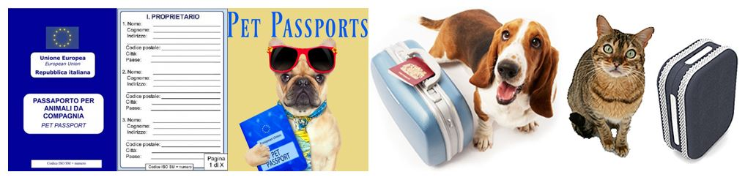

**How to get an ITALIAN Pet Passport & Health/Export Certificate**

1. By law, pet MUST be registered in the Italian ASL system. ***Failure to register your pet can result in a fine of €300,00+***

If you find or adopt or purchase a pet in Italy, you have 20 days to register it

If you import a pet to Italy, you have 90 days to register it

The TNR Italy Facebook group has the blank registration form and instructions under “files”. There is no cost to register.

If you do not know if your pet is registered in the Italian ASL system, you can use these links to enter your pet’s microchip number. If it is registered, the site(s) will tell you which ASL location they are registered at. If nothing is available in the search, it means your pet is not registered. The base vet local microchip database is not connected to the Italian ASL system.  
  
Campania ONLY - [http://www.anagrafecaninacampania.it/](http://www.anagrafecaninacampania.it/?fbclid=IwAR3T2A6A-adBvagHbeX5Hcx1CrZifecTi9WVXKU2ah3Qefdnsg8Ypfp9tU4)  
Italy - [http://www.salute.gov.it/anagcaninapublic_new/home.jsp](http://www.salute.gov.it/anagcaninapublic_new/home.jsp?fbclid=IwAR3amyC3djll73OatvdqbxCMpLbaRGITybQ6bhZk9tkpr51DWHXEr_hafDk)

2. The ASLs are an Italian government entity. They are not affiliated with the base veterinary clinic, any host nation veterinary clinic or the TNR Italy group. You MUST know which ASL office to go to and it is based on where you live. Each has their own payment requirement, area of responsibility, business hours and they are NOT interchangeable. The information in this document can change at any time.

3. ASL’s in Italy are responsible for people, pets, food safety and many other services. When you search for an ASL, be certain it is for veterinary (veterinario) or you may find yourself at the wrong location. This is the webpage to locate an ASL  [http://www.anagrafecaninacampania.it/index.php/ricerca-asl](https://l.facebook.com/l.php?u=http%3A%2F%2Fwww.anagrafecaninacampania.it%2Findex.php%2Fricerca-asl%3Ffbclid%3DIwAR2iuu8dRvmIOFF3lxf-qE6t2fIrFDXUREAckPb1u534ztRQ9lrn_9nHIA4&h=AT0-KT8JF3UOWvHnbIjPEMF0sYqc7QWZwdAnYsIQbPJFP5EN3-V2-LszOZsMFv1avLwuU5a1DLKqsnJ98KrivuJ12s0d8b8J3x2NzysjRROTHVktnVS1riFHKAfbWTsYeA&__tn__=-UK-R&c%5b0%5d=AT18qTM_WSOXHTB_Qzb3IjURHhUbamAc8zYAG1Bw9KALpGFn505uTY7G9riTQwyrp6967HDWNW4jTYzo6ZUJYoiNsS-li71fV8lvJRGXjfFdpso-lwVT0OZqnw2wCPeXRAZ2VLiGCHTqtCsCGG7asUq0HtK-YZvhtYQ)

4. A pet passport is required to travel on a commercial carrier within and out of Europe. You do not need a pet passport to fly on AMC/Rotator but it is recommended to have one in case you need to fly commercial or use a pet shipper.  
  
5. The rabies vaccination has to be 22+ days old to get the initial pet passport or to renew an existing pet passport.  
Example: rabies vaccination date 01Feb2022. Count 22 days equals 23Feb2022. From 23Feb2022 forward, you can get or renew the pet passport. Travel to EU countries and the UK is valid (the UK has additional requirements). Travel to the USA is valid on the 31st day after the rabies vaccination. For the most up to date information for ANY country, visit their official government website.

6. You have to have a pet passport before you can get an Italian, ASL issued, health/export certificate.

These are instructions for **3 specific ASL offices in the Campania** region which handle veterinary services. **Use the GPS coordinates provided for the best directions.** If you use an address, you may end up at the wrong location.

**Payment for services**

You must pay before you visit an ASL location. They do not accept any form of in office payments. If you pay the wrong ASL, you WILL NOT receive services or a refund. The payment is valid for 30 days so you can pay long before you visit. Payment detail is listed with each location. There are also photo examples.

The two way to pay are:

Bank transfer – You need the IBAN number

The easiest is to go to Community Bank on Capo. If you do NOT have an account, take cash. The price for non- account holders is $3.00. The price for account holders is $1.00. Account holders do have the option to set up a direct transfer with their online access, but the process can take a few days to complete. If you cannot go to Community Bank, you can go to a local Italian bank and follow their instructions.

Postal money order – You need the c/c number

There is an Italian Post Office inside the JFC NATO base (hours are Mon – Fri 0830 – 1330 and Sat 0900 – 1200). Many people find this the most convenient but ANY Italian post office can do the money order for €1,50. The form if filled out similar to a bank check. There are examples. One for a NEW pet passport and 1 for a health/export certificate. If you need a different service, the prices are listed below.

**PRICES as of 27 Apr 2022**

The fees are PER PET. Multiply for each pet the cost to determine the number needed.

|  |  |  |
| --- | --- | --- |
| **SERVICE** | **PRICE** | **HOW TO WRITE IN ITALIAN** |
| NEW pet passport | € 23,46 | ventitré e quarantasei centesimi |
| Health/Export certificate and exam | € 18,00 | diciotto e zero centesimi |
| RENEWAL of current pet passport | € 6,12 | sei e dodici centesimi |
|  |  |  |
| 2 new pet passports | € 23,46 * 2 = € 46,92 | quarantasei e novantadue centesimi |
| 1 new pet passport + health/export certificate | € 23,46 + € 18,00 = € 41,46 | quarantuno e quarantasei centesimi |

**Residents of Aversa, the Support Site, Castel Volturno and other nearby areas:**ASL2 Servizio Veterinario (Caserta) Office hours: Mon. Tues. Thurs 0900 - 1200  
GPS: 40.976663,14.1951093 Phone 081 500 1339 Fax 081 814 8900

Email: [randagismo@pec.aslcaserta.it](mailto:randagismo@pec.aslcaserta.it)

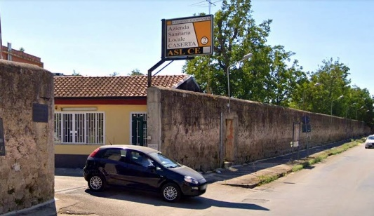

Note: Enter through the main gate, make the first right, go all the way to the end and park. The entrance is on the front of the building. (photo of main gate entrance)

Payment: *ONLY THIS LOCATION* has the option of either a bank transfer or postal money order for payments.

**BANK TRANSFER IBAN IT 62 N010 0514 9000 0000 0218 000**

**POSTAL MONEY ORDER c/c 15917818**

Examples in photos

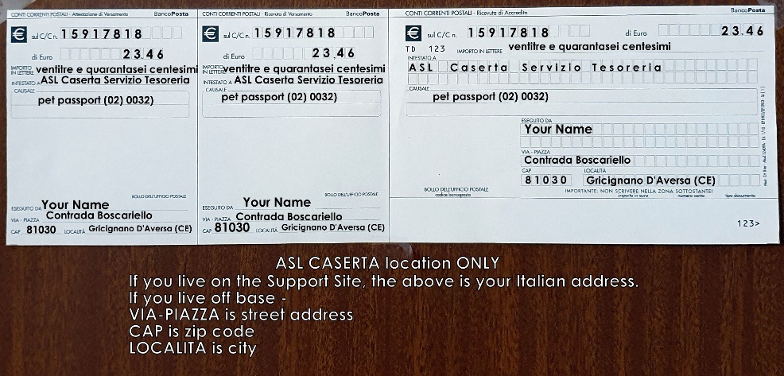

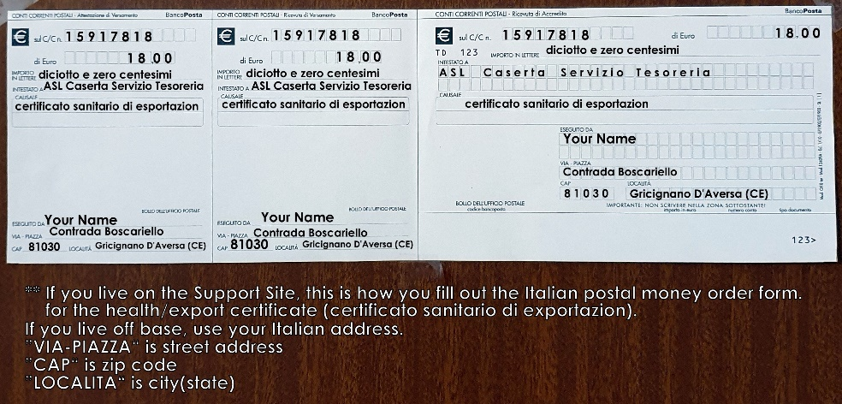

**Residents of Giugliano in Campania: Lago, Licola, Pozzuoli, and nearby areas:**ASL2NORD (Napoli 2 Nord) Office hours – Mon. Wed. Fri. 0900 – 1300

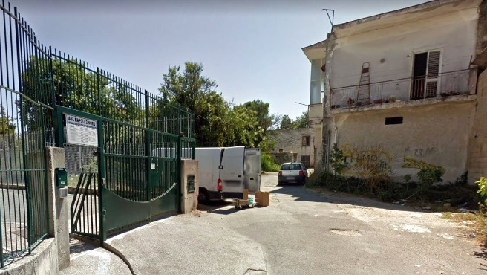GPS: 40.8976141,14.1753352 Phone 081 586 7105 Fax 081 742 4663  
 Email: [ospedaleveterinario@aslnapoli2nord.it](mailto:ospedaleveterinario@aslnapoli2nord.it)

Note: Parking is extremely limited

(photo of entrance and parking area)

**Payment: BANK TRANSFER IBAN IT 24 E030 6940 1031 0000 0300 014**

**Residents of Naples:**  
ASL NAPOLI 1 CENTRO Veterinario Office hours: Mon – Fri 0900 – 1300 & 1500 – 1900 Sat 0900 - 1300   
GPS cords: 40.8781763,14.2278504 Phone 081 254 9596 / 081 254 9598 / 081 254 9980

Email: [pov.a@aslnapoli1centro.it](mailto:pov.a@aslnapoli1centro.it)

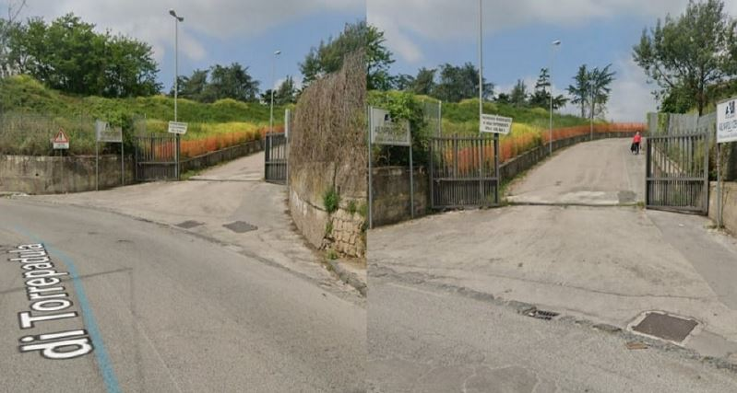

Note: Ask the gate guard where the

“ufficio” (office) is

(photo of the compound entrance)

**Payment: POSTAL MONEY ORDER c/c 41136177**

Examples in photos

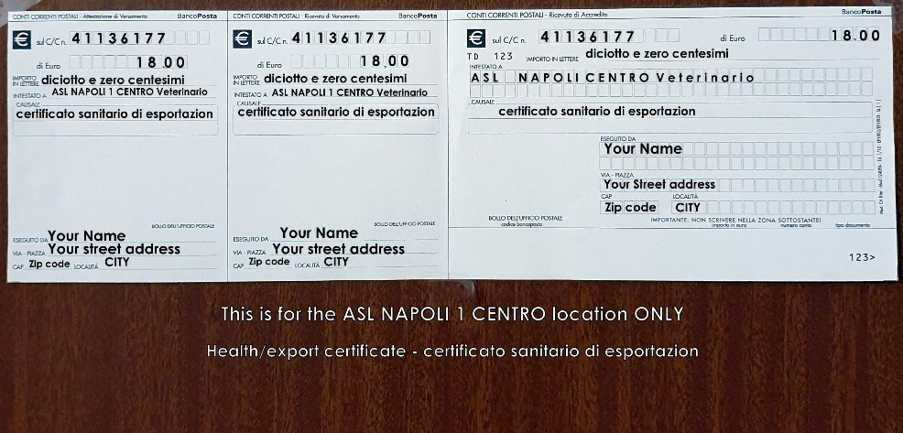

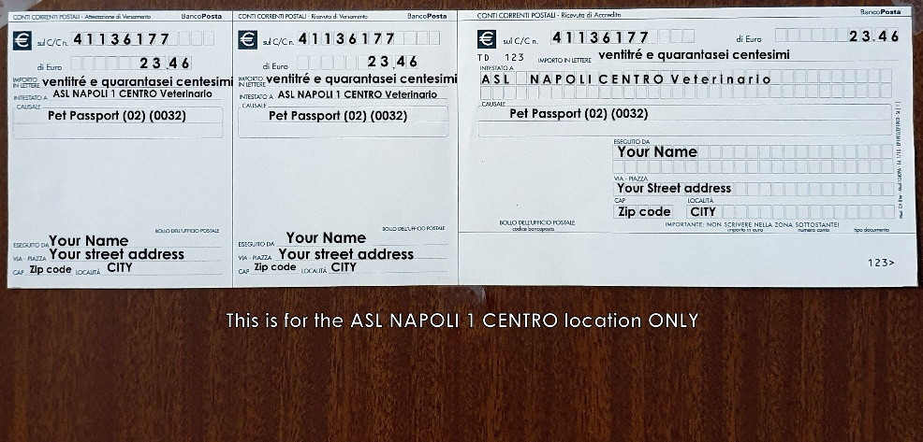

You can use a single postal money order or bank transfer for multiple services for same day services.  
 Example: you need two pet passports for two pets can be made with one money order/bank transfer  
 If you will have multiple services but on different days, you need 2 payments.

Example: pet passport on one day and a health/export certificate at a later date

**WHAT YOU NEED TO TAKE for Pet Passports**

REGISTERED pets UNREGISTERED pets  
1. Your PET(s) 1. Your PET(s)  
2. ORIGINAL rabies certificates 2. ORIGINAL rabies certificates  
3. Proof of payment 3. Proof of payment

4. Your photo ID. Passport or driver’s license 4. Your photo ID. Passport or driver’s license  
 5. Your codice fiscale  
 6. The completed registration form  
 7. Proof of address - lease, bill, etc. (*this is not always checked/requested at the ASL)  
  
IF YOU LIVE ON THE SUPPORT SITE - This is the address the ASL2 Aversa uses, NOT your PSC/FPO address.  
  
Contrada Boscariello  
81030 Gricignano di Aversa (CE)

**WHAT YOU NEED TO TAKE for Health/Export Certificate**

**Only the ASL can issue the Italian Health/Export certificate** required by pet shippers and commercial airlines. *The base vet clinic can issue a health certificate but NOT the required Export certificate.* The AMC/Rotator only require a valid rabies certificate and a health certificate.  
  
1. Your PET(s) 4. Your photo ID. Passport or driver’s license  
2. ORIGINAL rabies certificate 5. Pet passport   
3. Proof of payment   
  
  
ALWAYS search the requirements of your DESTINATION country you are moving to. Important, reliable links are: https://www.aphis.usda.gov/aphis/pet-travel?fbclid=IwAR3AkLF4LVhBnlJot0jk9BFPkXIkAOO7IcYTYPhzWMxroX4McDQwseRRup8  
Pets to/from Italy and USA  
https://it.usembassy.gov/embassy-consulates/rome/sections-offices/foreign-agricultural-service/pet-travel-faqs-italy-u-s/  
  
For other countries Google "shipping pets FROM <insert country> TO <insert country>" Look for official government links.